## How The Web Works

### *The Structure of WWW

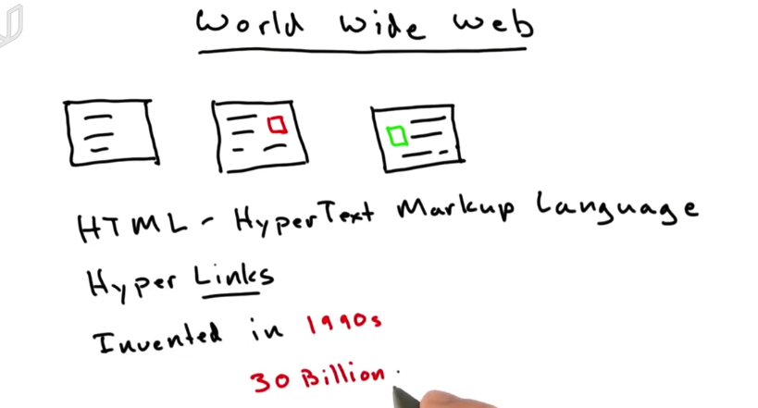

WWW is a collection of HTML documents. Almost every webpage is based on HTML.

HTML links to each other by hyper-links, which makes the network like a web.

All other types of document like picture, video, radio, etc can exist on the web. But HTML is the main content in the web.

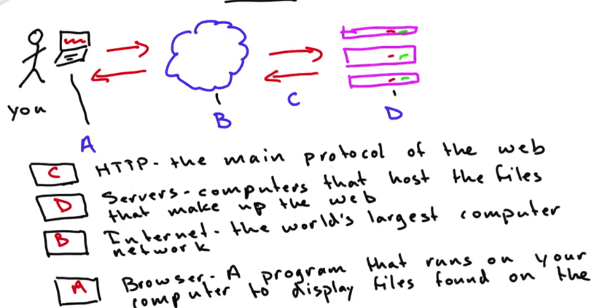

Your computer makes request via internet to service. These requests are using a protocol called HTTP. The server responds with files that your browser displays.

Servers are just like your computer. They sit in a closet and host the files.

### What Is HTML?

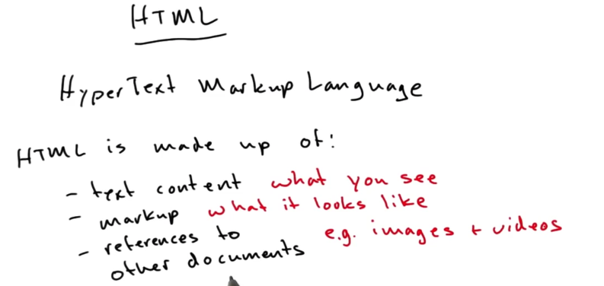

HTML is made up of content, markup and other resources.

Content and markup is separated which means you can develop them separatedly.

### HTML Elements

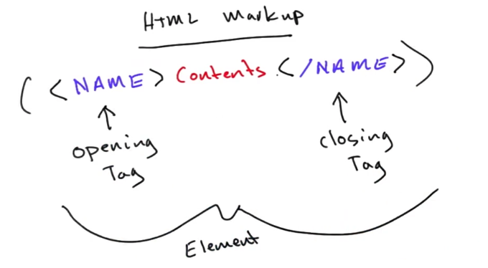

<b></b>

<em></em>

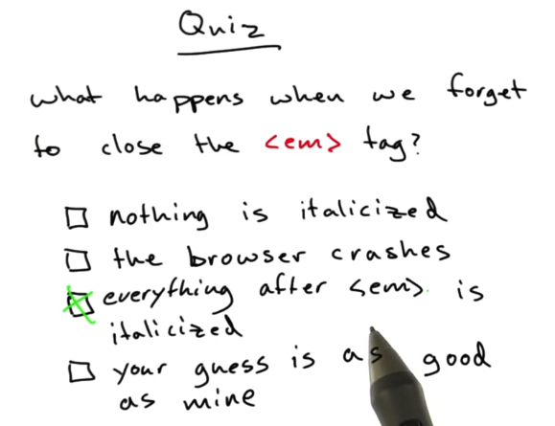

#### <a>

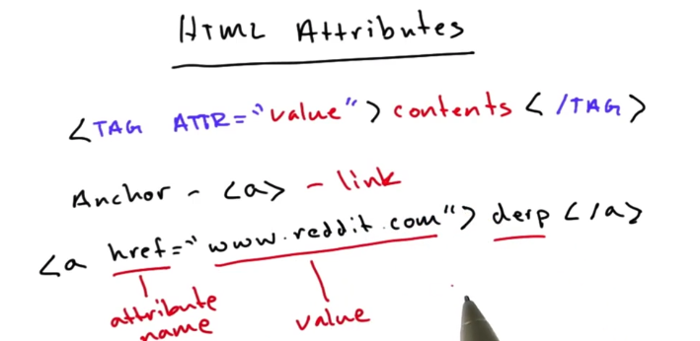

a for anchor, which is to make links.

These are still tags. But inside the opening tag, you can add some attribute=”value” pairs to it.

#### <img>

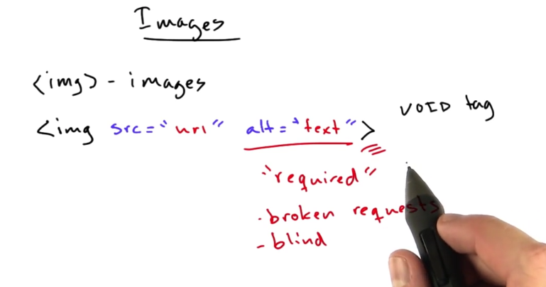

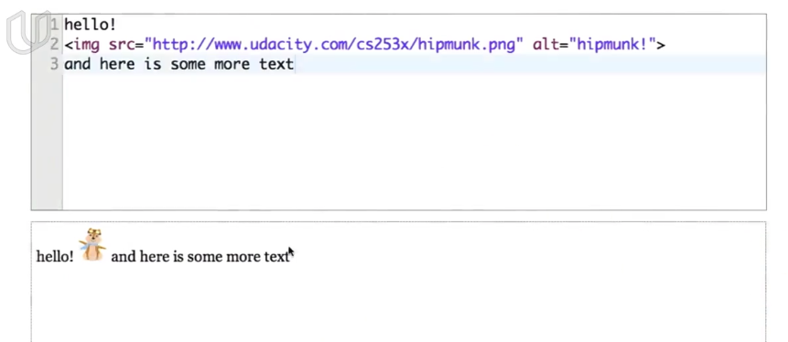

<img src = “url to download the image” alt=”if not download successfully, the alternative content will show”>

No content for image tag. No closing tag.

#### <br>

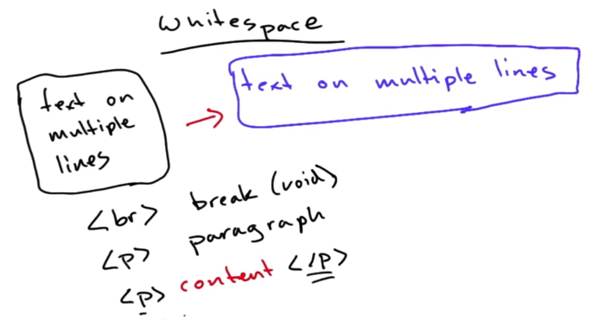

To turn to a new line, you can use <br> tag or <p> tag

#### <p>

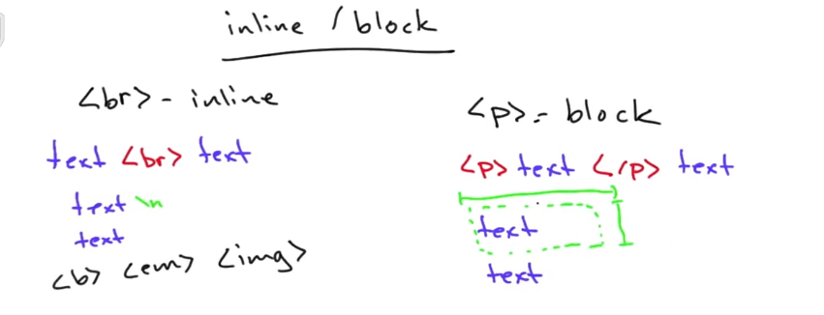

Inline element, just text.

Block element actually makes a invisible box, which has height, width, color, etc.

#### <span> & <div>

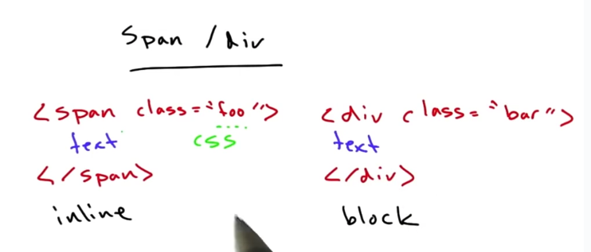

Span and div are just container of text. They can control how text is laid out.

You can attach style to them by declaring class attribute

#### Structure of HTML Document

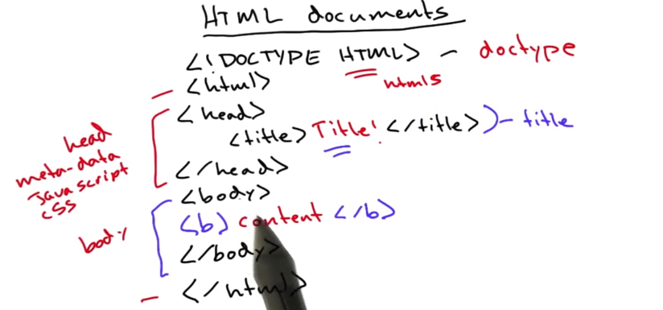

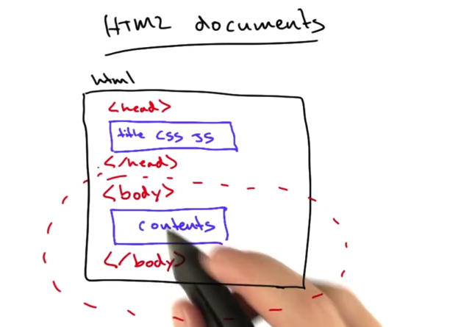

### *URL

#### Protocol & Host & Path

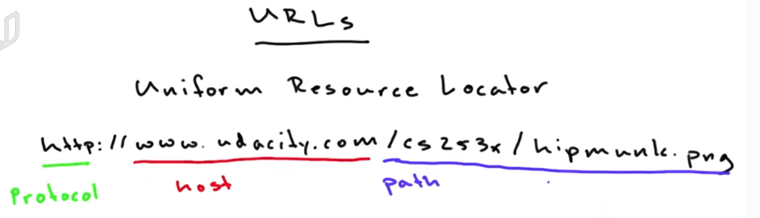

Host: This is the host name or domain name of the server which has the document that we want to access. The host can also be an IP address. The host will translate the host name into an IP address. The path specifies where to fetch the document inside the server.]

#### *Query Parameters

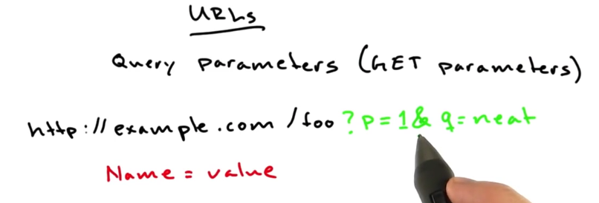

Query parameters in URL: question mark in the head and & to connect multiple query parameters.

#### Fragment

Fragments is to reference the particular part of the page you’re looking at. It will not be sent to the server. It just be kept in browser.

#### Port

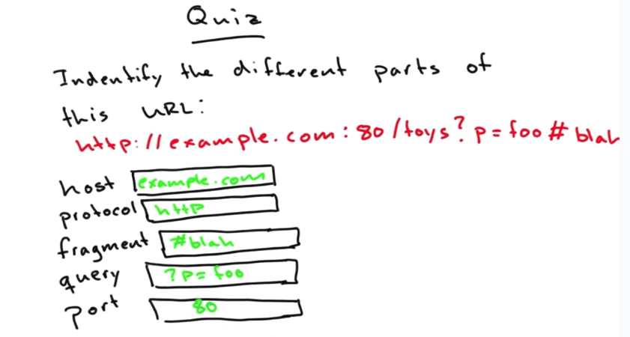

### HTTP

#### HTTP Request

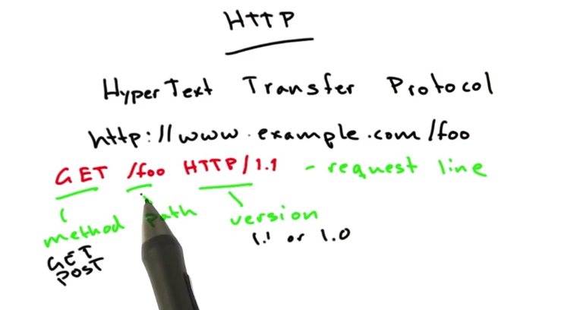

Http is the main protocol of the web. HTTP is what the browser used to talk to the web server.

Host name is used to make connect. The path is used to make request.

Your browser will send some kind of request line to the server.

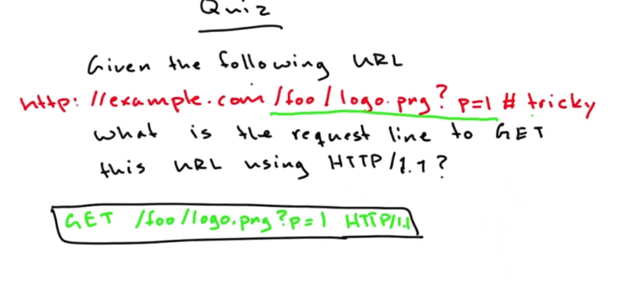

The fragment stays in the client side.

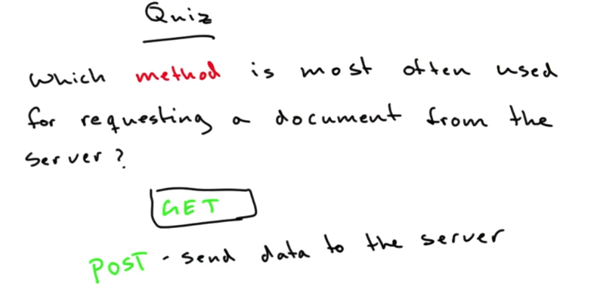

GET is to request documents from the server.

POST is to send data to the server.

#### *HTTP Request Headers

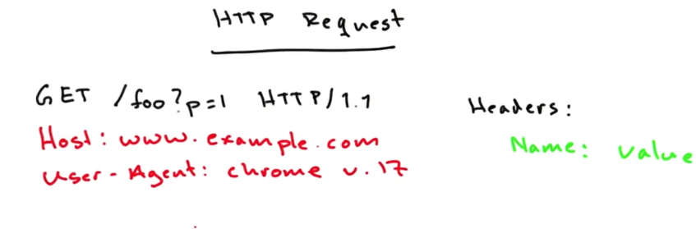

The request line is followed by the headers, which has Name:Value format.

One name is the host. Although your browser already connect to the server, but the same server may contain multiple website. The head specifies which website you are requesting.

User-agent tells who is making the request.

Value can be anything you want. But an honest user-agent head will help to maintain good web environment for everyone.

#### *HTTP Responses

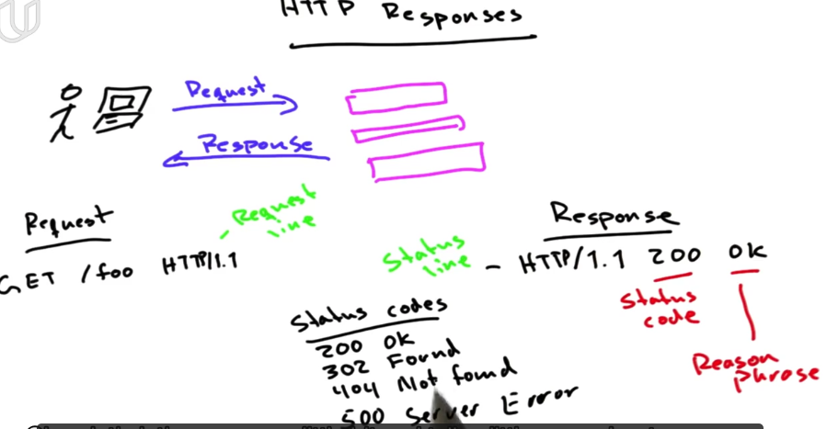

HTTP response: status codes start with 4 digits:

2: success 3: potentially success but need some adjustment

4: error on client side 5:error on server side.

### Servers

#### Web Application

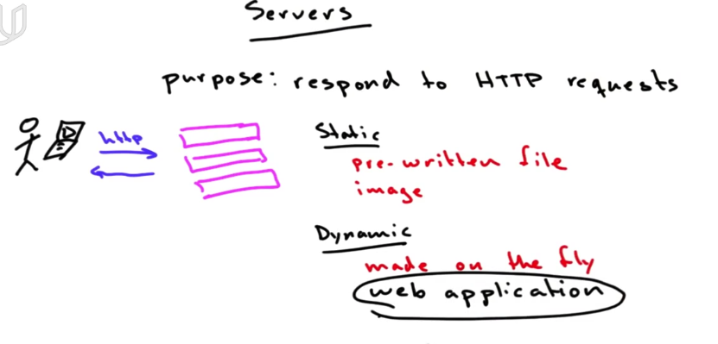

The kinds of request made to the server: static or dynamic.

Dynamic request: the response is built on the fly by a program that’s running, called web application.

Web applications execute in web server, speak http and generate content that your browser request.

## Forms and Input

<form action = “www.google.com/search”>

<input name = ”q”>

<input type = “submit”>

</form>

When you press submit, suppose you enter “udacity” in input form. Then the url will change to original url attached with ?q=udacity.

In form, if you add attribute action =”www.google.com/search”. Then after press submit button, the url becoms [www.google.com/search?q=udacity](http://www.google.com/search?q=udacity)

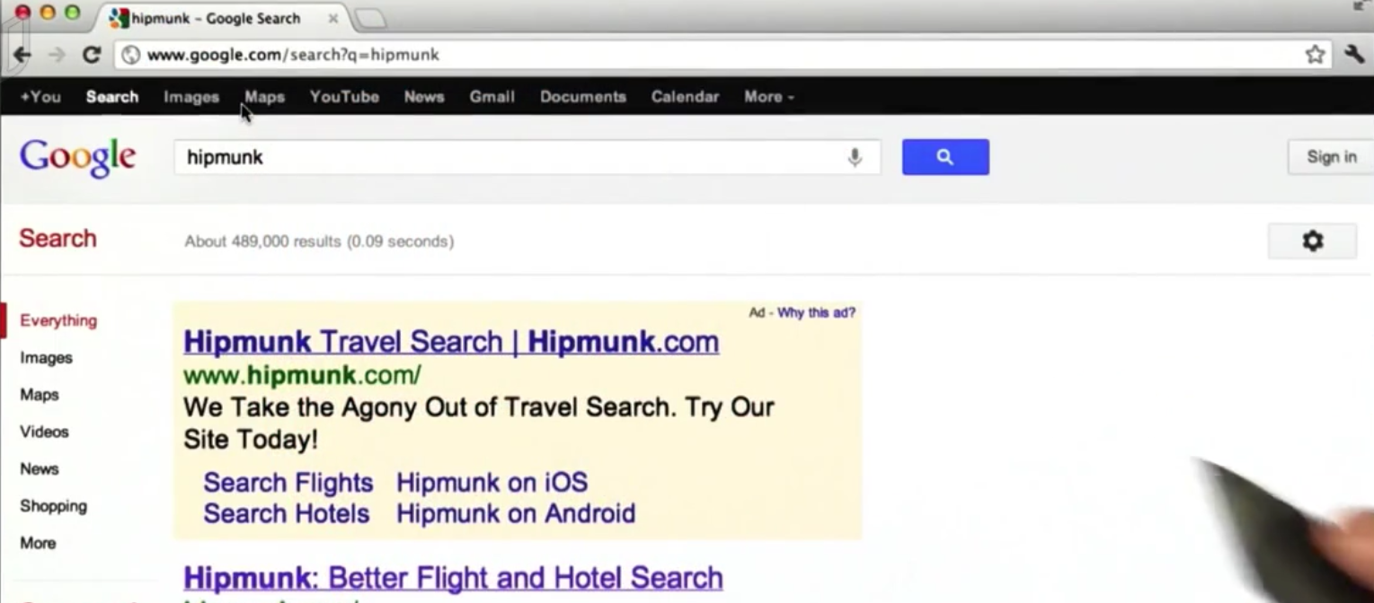

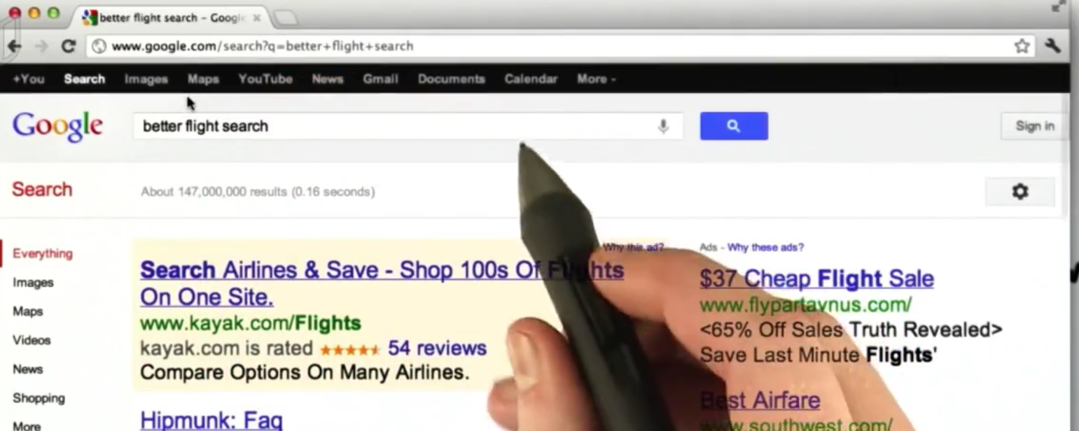

If you type several words with blanks, the result will be q=word1+word2+…

## *Ping

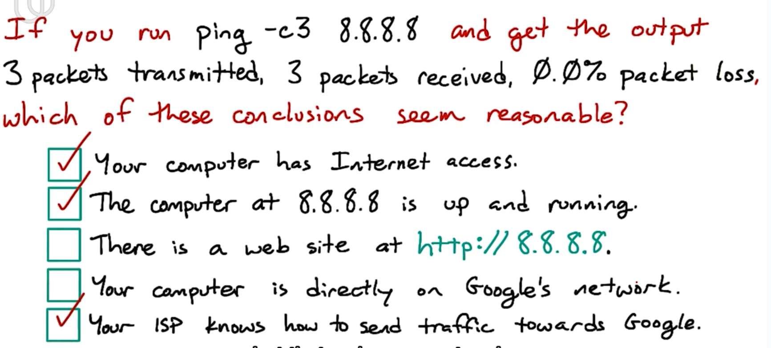

ping -c3 8.8.8.8

8.8.8.8 is an address of particular service on the Google.

**Ping is a command for testing whether your computer can send and receive network traffic with that address. Ping is also a kind of protocol.**

-c3 means to send 3 test messages.

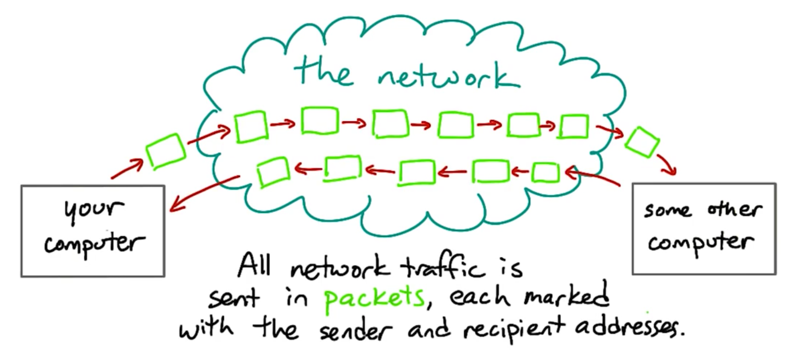

All traffic on the Internet is split into messages called packets

A packet is a short message that send from one computer to anther with the sender’s address and receiver’s address.

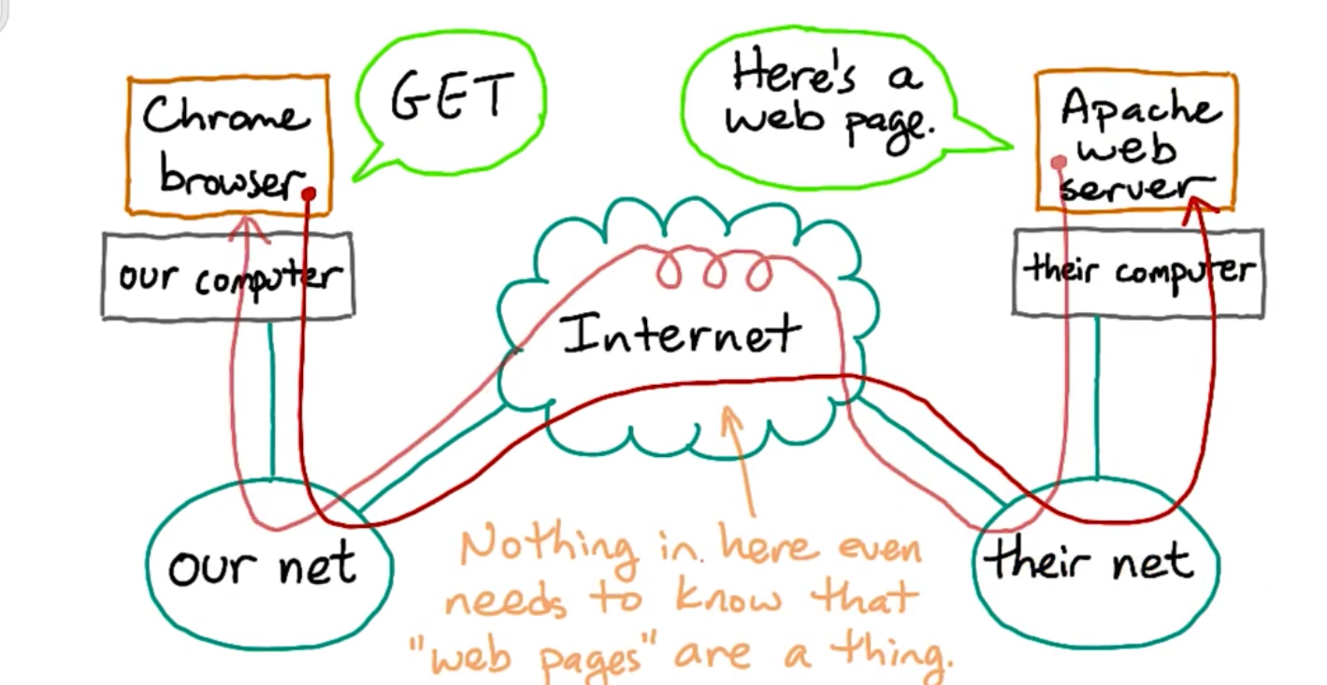

If you make a HTTP request and try to get a html page from the web server.

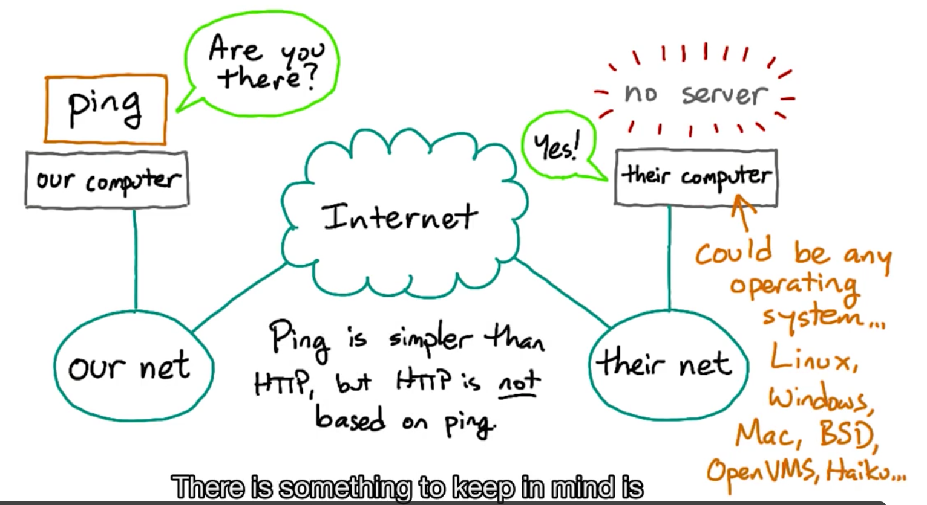

The ping request will goes to the operating system of the receiver. There is no ping server.

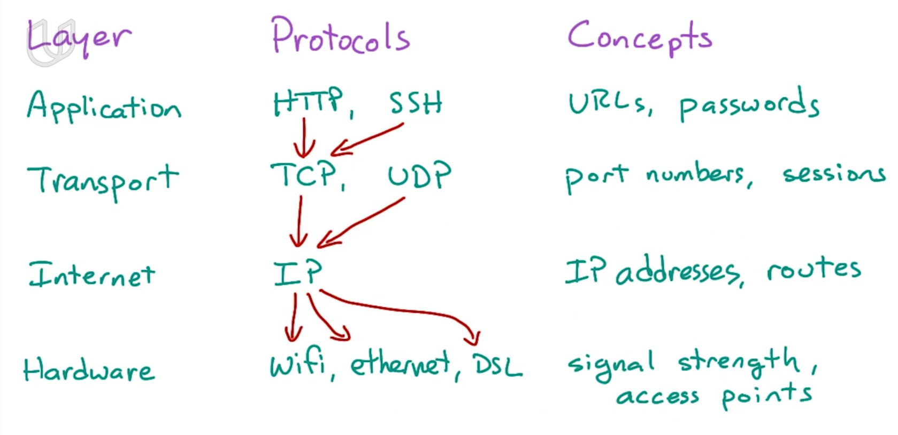

## *IP Address and DNS

IP address is used to designate a particular destination on the internet.

Everything transmitted on the internet is split into packets. And every packet has the IP address of where it comes from and where it goes.

Host: host is a machine that might host services.

When you ping an host name, you will get ip address. The ip address could be different because Google wants to balance the overhead among their data centers.

How is a host name translated into ip address? DNS

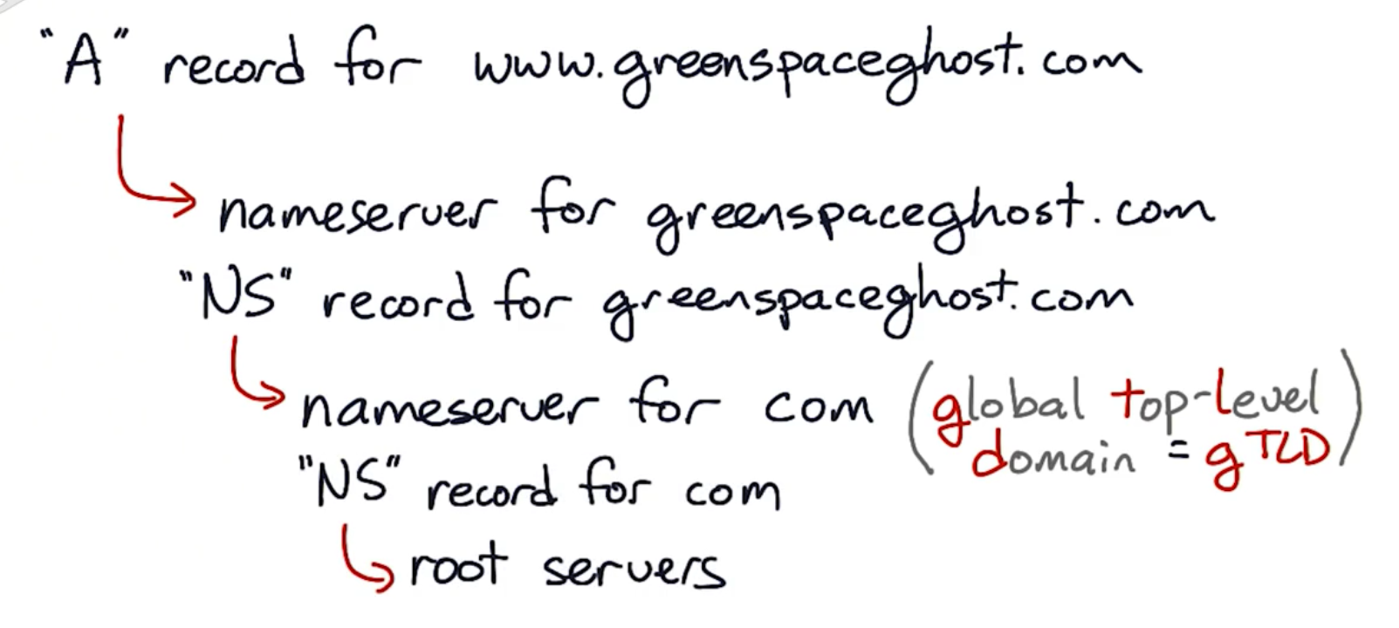

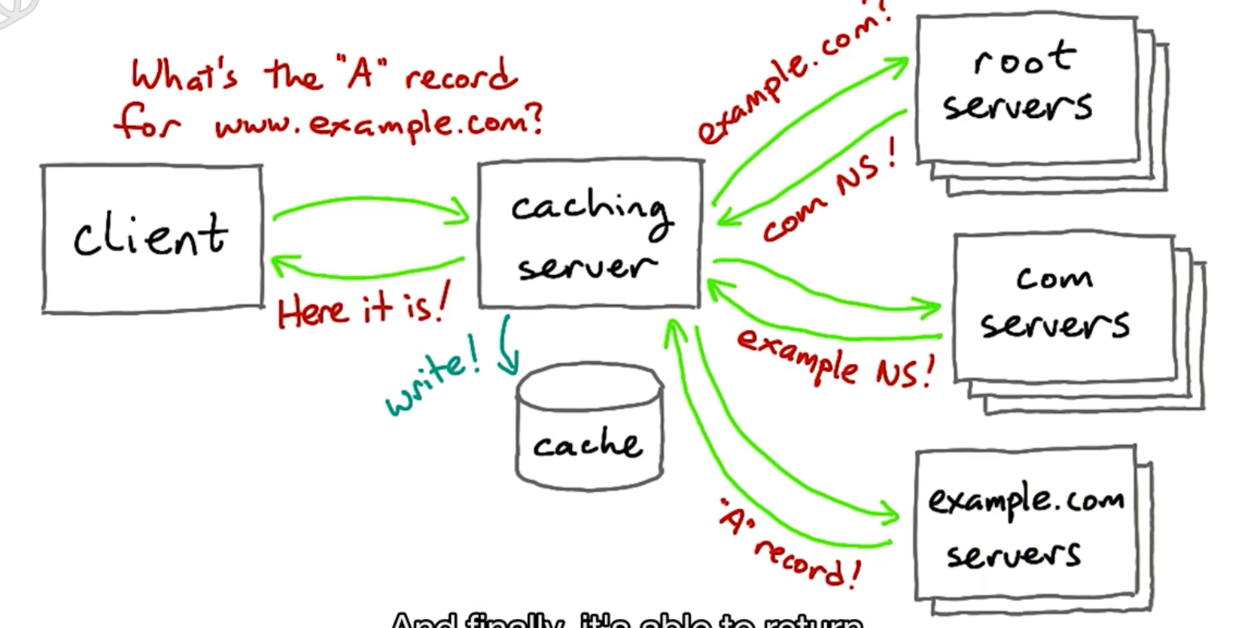

When client wants to get the ip address for a URL, first search in cache. If not exist here, use DNS to search for the ip address.

DNS is divided into several levels. The gloval top-level domain is like com org edu. DNS will search each level from the top one to the bottom until the address is found.

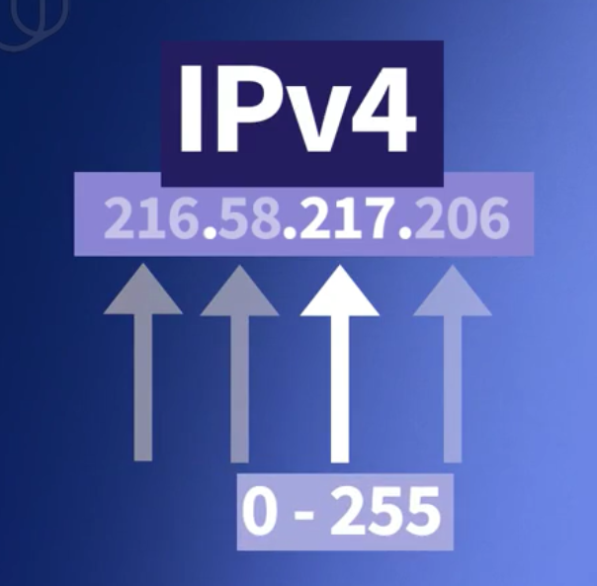

Ipv4: 4 numbers, each number is 8 bits.

## *Netblock and Router

Computers on the same network usually have the similar ip address.

All the addresses on the same netblock share the common prefix. They can communicate with each other without router.

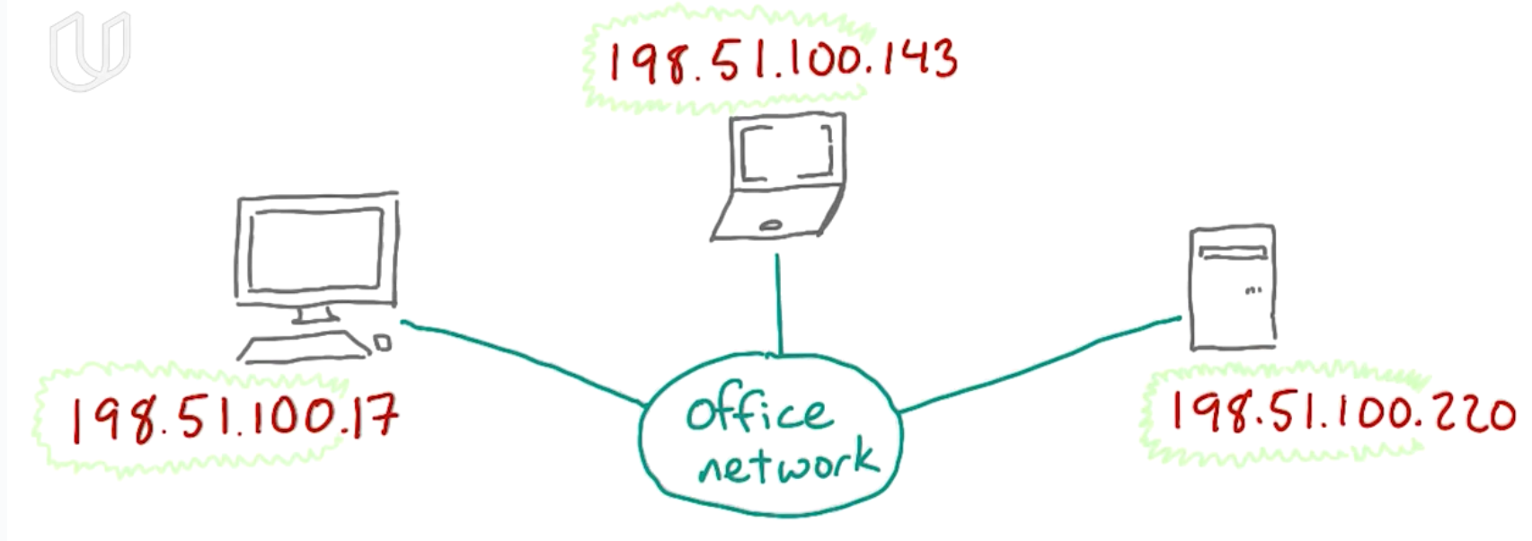

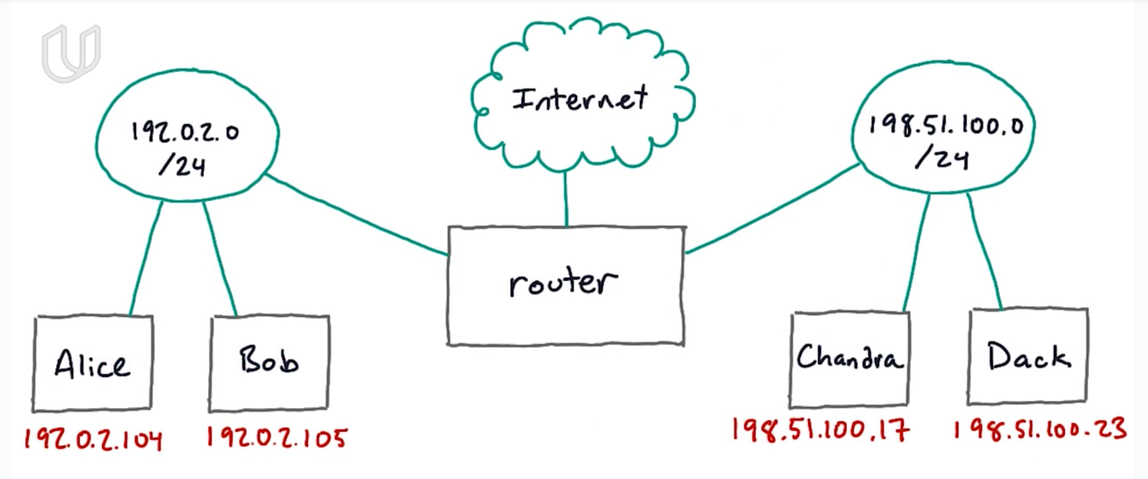

A router is a device that connects two different IP **netblocks**. It acts like gateway.

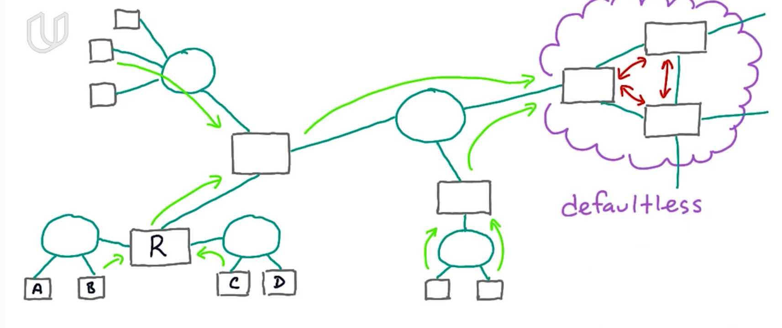

## *Protocol Layer

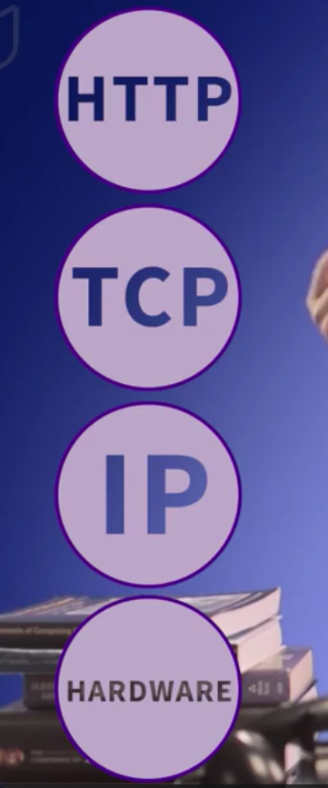

Each layer depends on the layer below and will hide the implementation details to simplify.

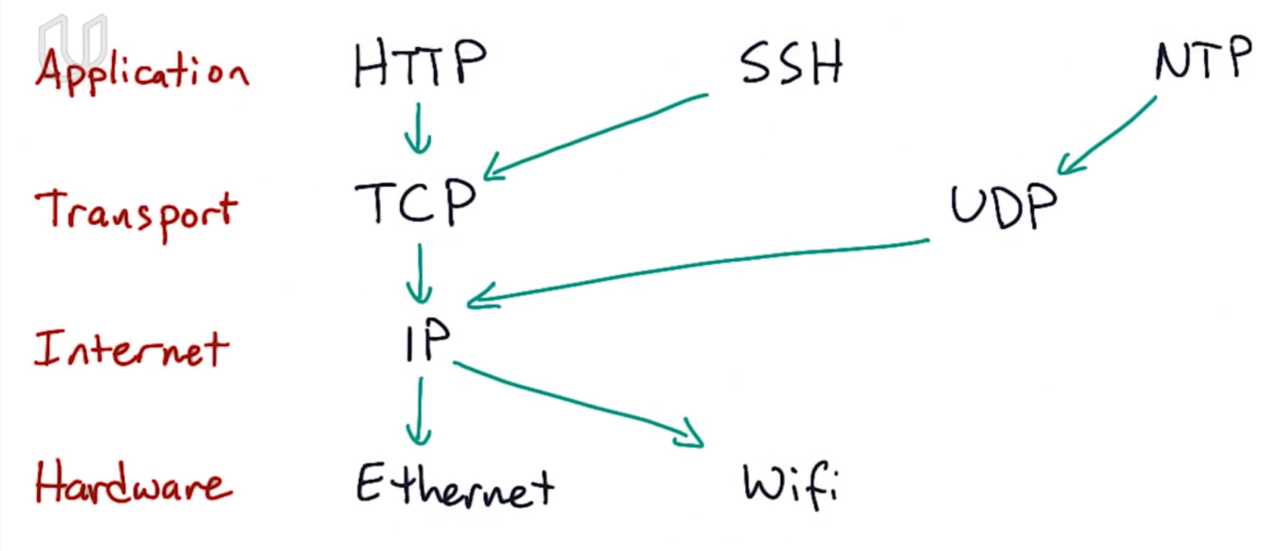

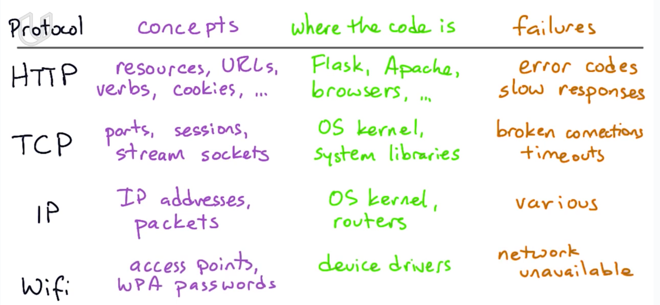

HTTP, TCP, IP are three protocols in application, transportation and internet layers.

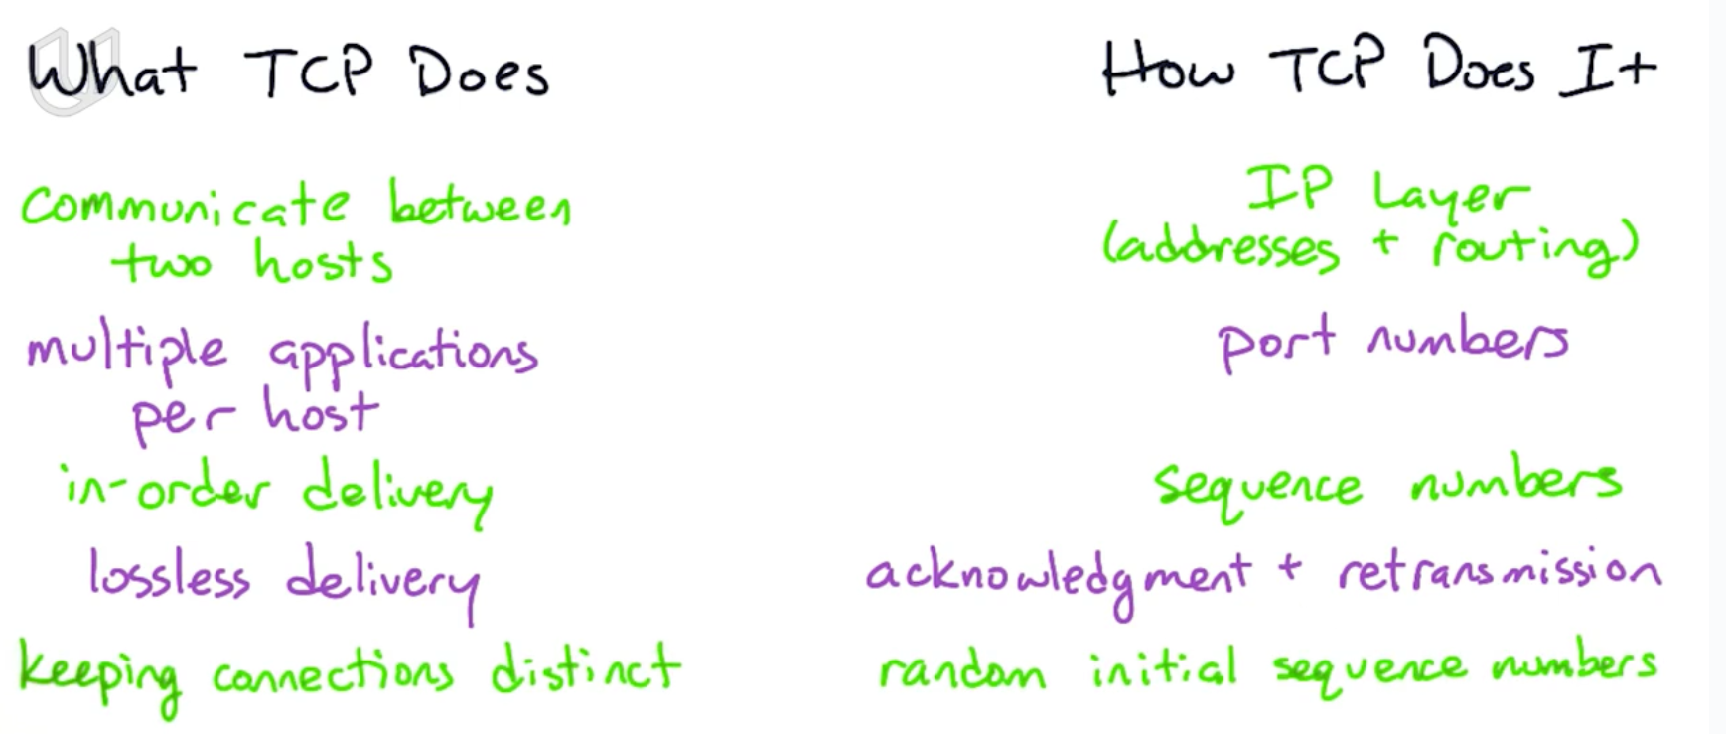

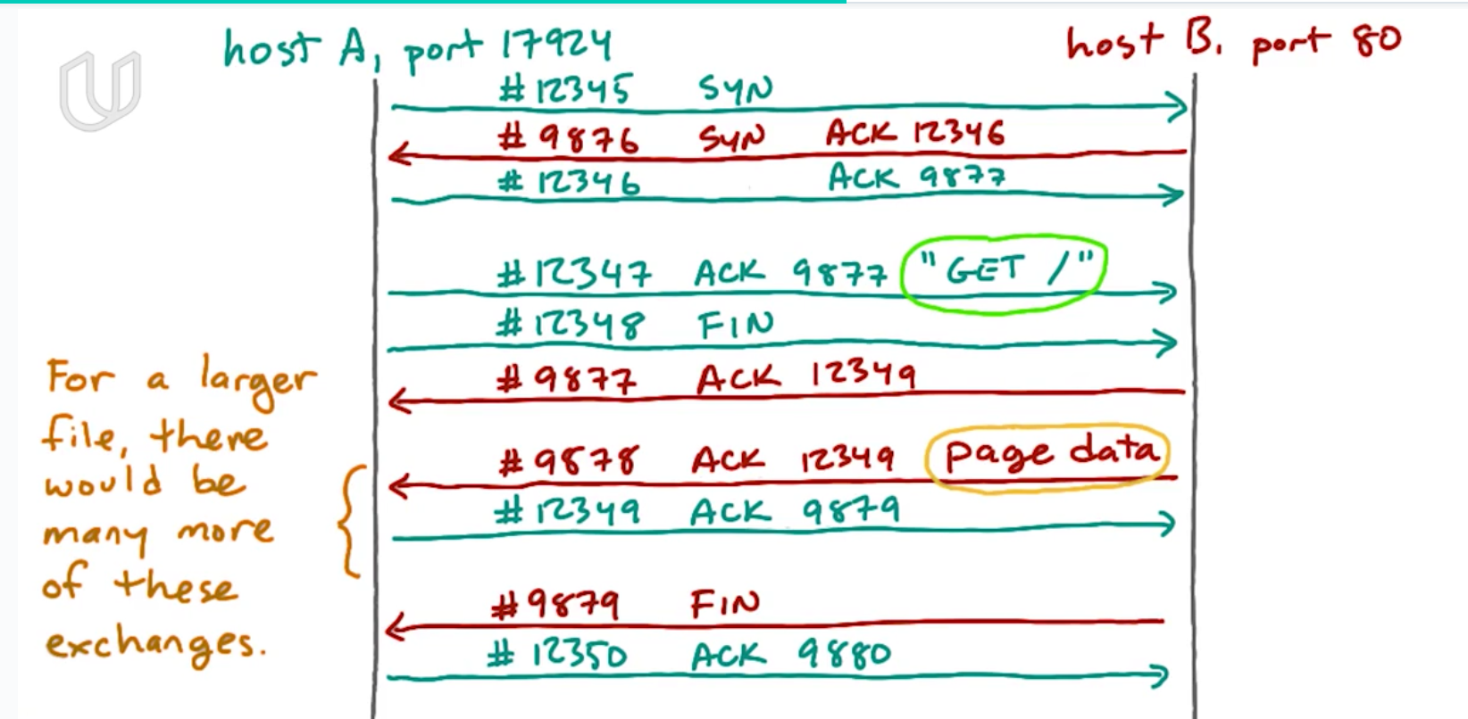

At first, the client knows the host’s ip address and port number, but the host does not know anything about the client. So client will send a packet about its ip address and port.

TCP also keeps track of the data that each endpoint is sent and make sure the other endpoint has received it. TCP will put a sequence number on each packet. Each endpoint will send an acknowledgement indicating when it’s received a particular sequence number. If any sequence number is missing, the endpoint will re-transfer that packet.

## *TCP／IP

When an endpoint A wants to build connection between endpoint B, first A will send a packet including sequence number, A’s ip address and A’s port number(first handshake). After B receives this packet, B will send back a packet including a new sequence number and the original sequence number, indicating that B has received A’s first packet(second handshake).

Until now, A knows both A and B can send and receive packets. But B only knows he can receive packet and A can send packet. B does not know if he can send packet and A can receive packet. So A will send another packet telling B that A has received B’s message(third handshake).

After 3-way handshake, the connection between A and B is built.

IP协议负责把数据从一台计算机通过网络发送到另一台计算机。数据被分割成一小块一小块，然后通过IP包发送出去。由于互联网链路复杂，两台计算机之间经常有多条线路，因此，路由器就负责决定如何把一个IP包转发出去。IP包的特点是按块发送，途径多个路由，但不保证能到达，也不保证顺序到达。

TCP build a reliable connection between two computers using three handshakes. It garantue IP packages will be received otherwise it re-send the package.

TCP协议则是建立在IP协议之上的。TCP协议负责在两台计算机之间建立可靠连接，保证数据包按顺序到达。TCP协议会通过握手建立连接，然后，对每个IP包编号，确保对方按顺序收到，如果包丢掉了，就自动重发。

一个IP包除了包含要传输的数据外，还包含源IP地址和目标IP地址，源端口和目标端口。

端口有什么作用？在两台计算机通信时，只发IP地址是不够的，因为同一台计算机上跑着多个网络程序。一个IP包来了之后，到底是交给浏览器还是QQ，就需要端口号来区分。每个网络程序都向操作系统申请唯一的端口号，这样，两个进程在两台计算机之间建立网络连接就需要各自的IP地址和各自的端口号。

## Others

The browser is responsible to translate the URL, finds the server, build connection and send request. After the server sends the required data(usually HTML document) back, the browser is responsible to show the data to client(namely read the HTML document).

HTTP is the protocal that browser use to communicate with the server

## Socket

socket是在应用层和传输层之间的一个抽象层，它把TCP/IP层复杂的操作抽象为几个简单的接口供应用层调用已实现进程在网络中通信。

Socket是网络编程的一个抽象概念。通常我们用一个Socket表示“打开了一个网络链接”，而打开一个Socket需要知道目标计算机的IP地址和端口号，再指定协议类型即可。

## UDP

TCP是建立可靠连接，并且通信双方都可以以流的形式发送数据。相对TCP，UDP则是面向无连接的协议。

使用UDP协议时，不需要建立连接，只需要知道对方的IP地址和端口号，就可以直接发数据包。但是，能不能到达就不知道了。

虽然用UDP传输数据不可靠，但它的优点是和TCP比，速度快，对于不要求可靠到达的数据，就可以使用UDP协议。

## HTTP

步骤1：浏览器首先向服务器发送HTTP请求，请求包括：

方法：GET还是POST，GET仅请求资源，POST会附带用户数据；

路径：/full/url/path；

域名：由Host头指定：Host: www.sina.com.cn

以及其他相关的Header；

如果是POST，那么请求还包括一个Body，包含用户数据。

步骤2：服务器向浏览器返回HTTP响应，响应包括：

响应代码：200表示成功，3xx表示重定向，4xx表示客户端发送的请求有错误，5xx表示服务器端处理时发生了错误；

响应类型：由Content-Type指定；

以及其他相关的Header；

通常服务器的HTTP响应会携带内容，也就是有一个Body，包含响应的内容，网页的HTML源码就在Body中。

步骤3：如果浏览器还需要继续向服务器请求其他资源，比如图片，就再次发出HTTP请求，重复步骤1、2。

了解了HTTP协议和HTML文档，我们其实就明白了一个Web应用的本质就是：

1. 浏览器发送一个HTTP请求；
2. 服务器收到请求，生成一个HTML文档；
3. 服务器把HTML文档作为HTTP响应的Body发送给浏览器；

浏览器收到HTTP响应，从HTTP Body取出HTML文档并显示。

## Web框架

## web app： different url may refer to different http request, including GET, POST, PUT, DELETE. Programming on server is how to respond to different http request.

有了Web框架，我们在编写Web应用时，注意力就从WSGI处理函数转移到URL+对应的处理函数，这样，编写Web App就更加简单了。

在编写URL处理函数时，除了配置URL外，从HTTP请求拿到用户数据也是非常重要的。Web框架都提供了自己的API来实现这些功能。Flask通过request.form['name']来获取表单的内容。

使用模板，我们需要预先准备一个HTML文档，这个HTML文档不是普通的HTML，而是嵌入了一些变量和指令，然后，根据我们传入的数据，替换后，得到最终的HTML，发送给用户：